**ARYAMAN MISHRA**

**19BCE1027**

**LAB 05**

**Implementation**

hsb2=read.csv('C:\\Users\\aryam\\Desktop\\Fall Sem 2021\\Data Visualization Lab\\LAB 5 31-8-21/hsb2.csv')

attach(hsb2)

library(lattice)

hsb2$ses.f = factor(hsb2$ses, labels=c("low", "middle", "high"))

colors = c("red", "yellow", "green", "violet", "orange","blue", "pink", "cyan")

barchart(~write, hsb2,col=colors)

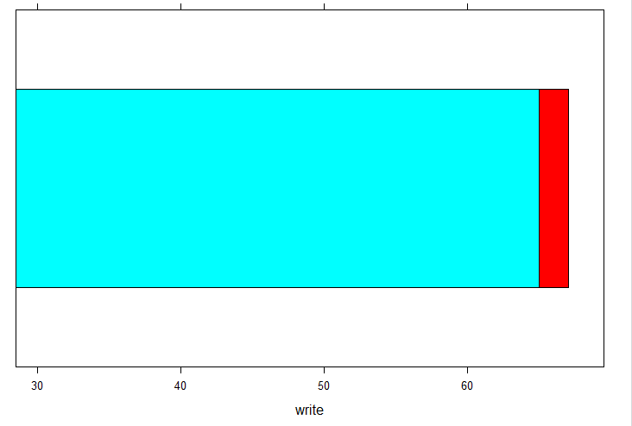

histogram(~write, hsb2,col=colors)

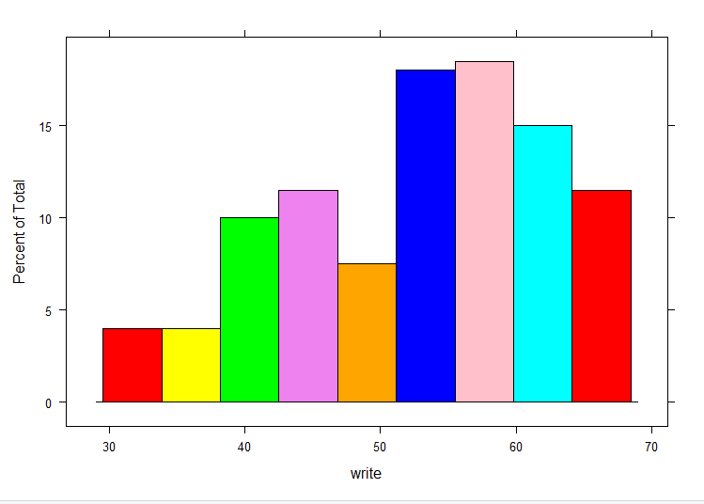

histogram(~write | ses.f, hsb2,col=colors)

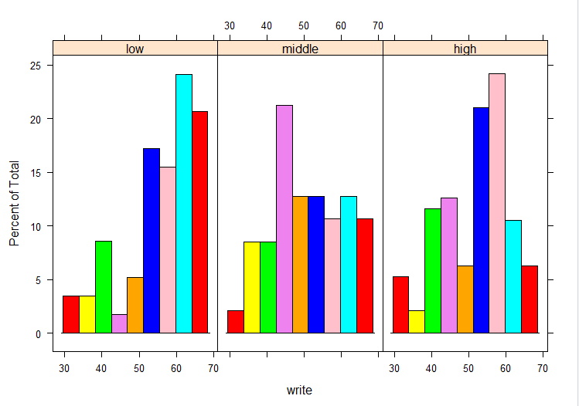

densityplot(~socst, hsb2,col=colors)

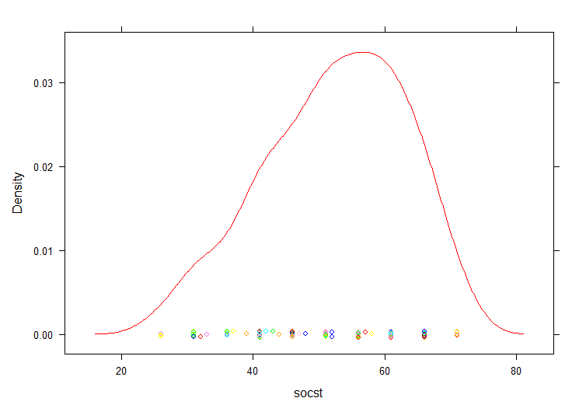

densityplot(~socst | ses.f, hsb2,col=colors)

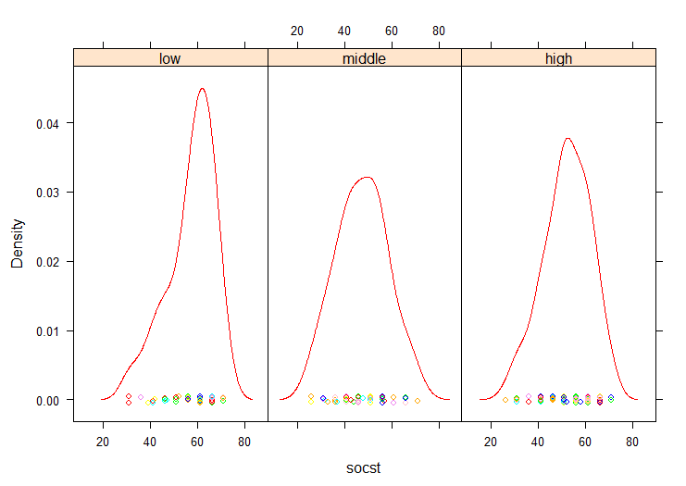

qqmath(~write, hsb2,col=colors)

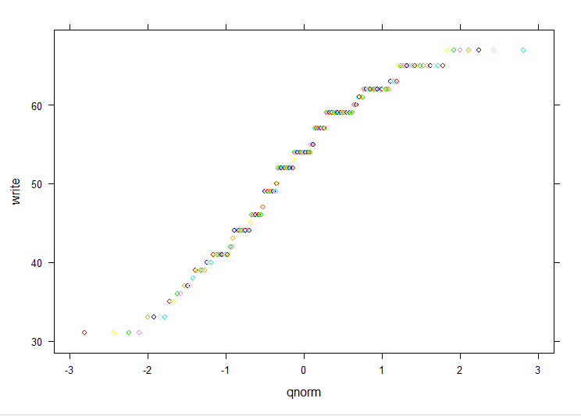

qqmath(~write | ses.f, hsb2,col=colors)

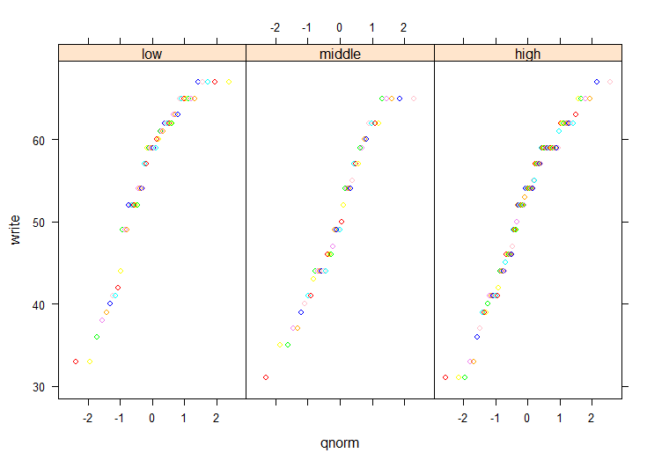

bwplot(~math, hsb2,col=colors)

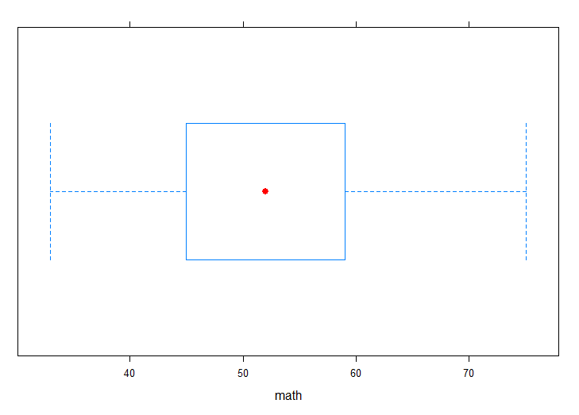

bwplot(ses.f~math, hsb2,col=colors)

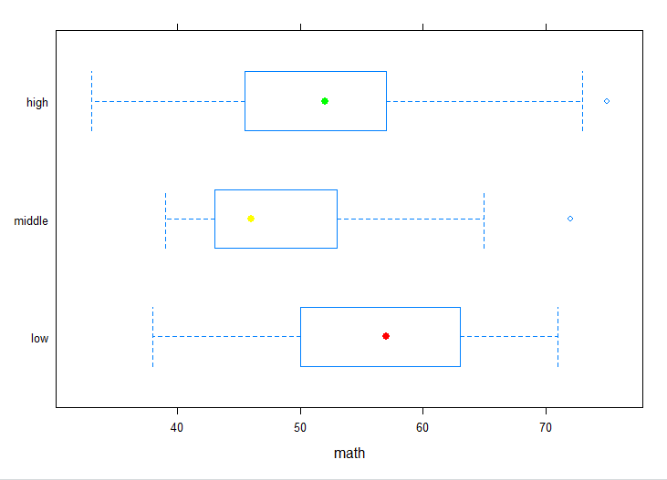

xyplot(write~math, hsb2,col=colors)

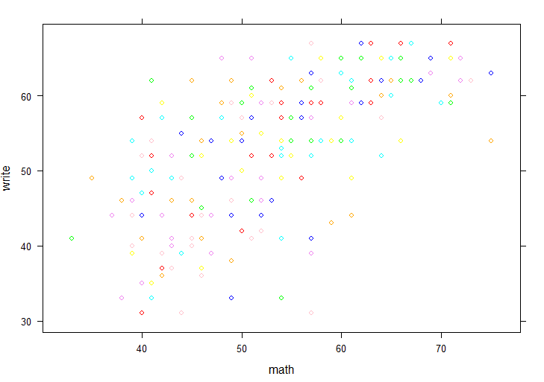

xyplot(write~math | ses.f, hsb2,col=colors)

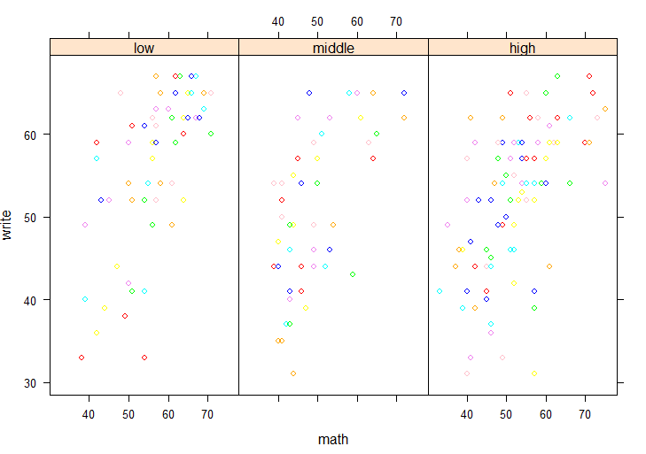

subset <- hsb2[ , 8:12]

splom(~subset[ , 1:4])

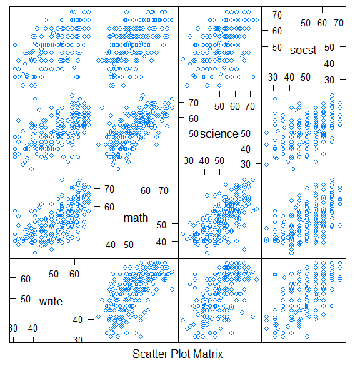

splom(~subset[, 1:3] | subset[, 5])

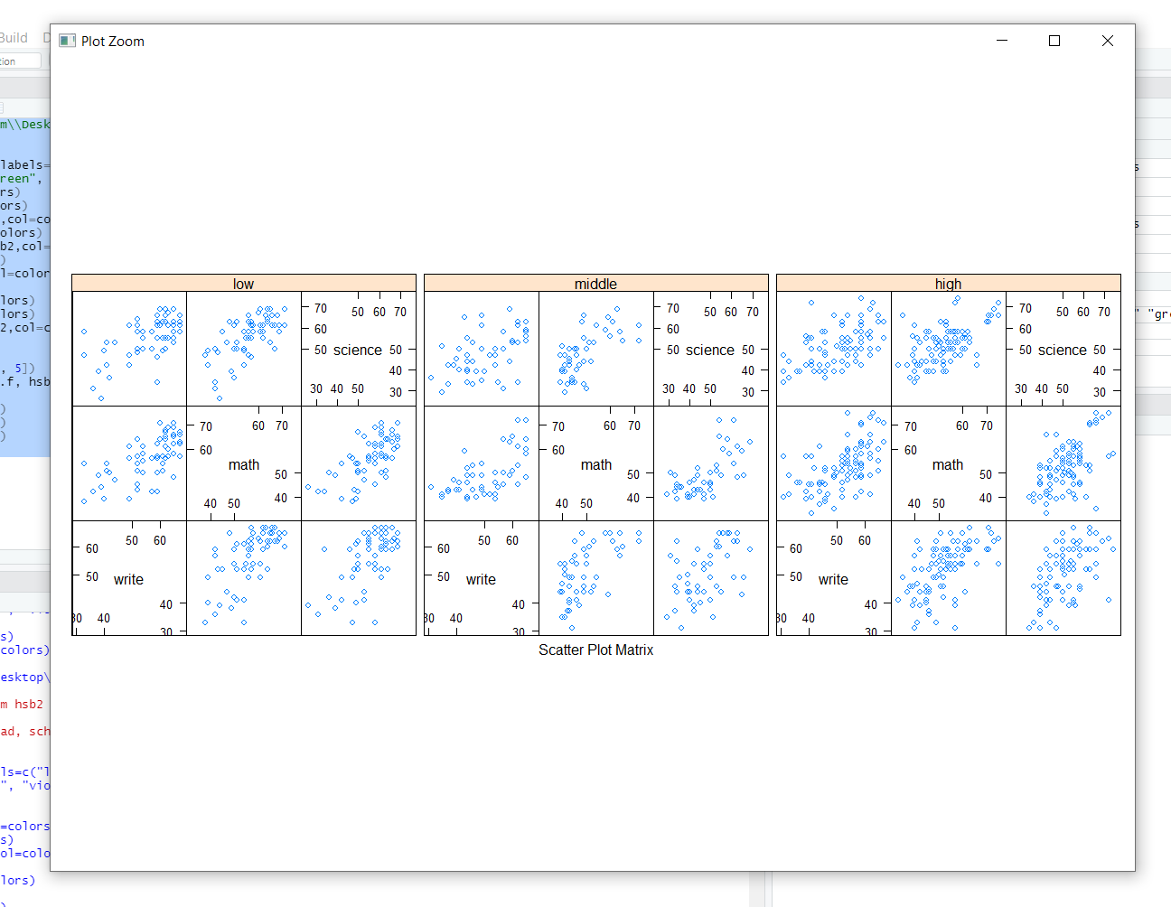

reg <- lm(write~math+socst+ses.f, hsb2)

par(mfrow=c(3,2))

plot(reg, which=1:2,col=colors)

plot(reg, which=3:4,col=colors)

plot(reg, which=5:6,col=colors)

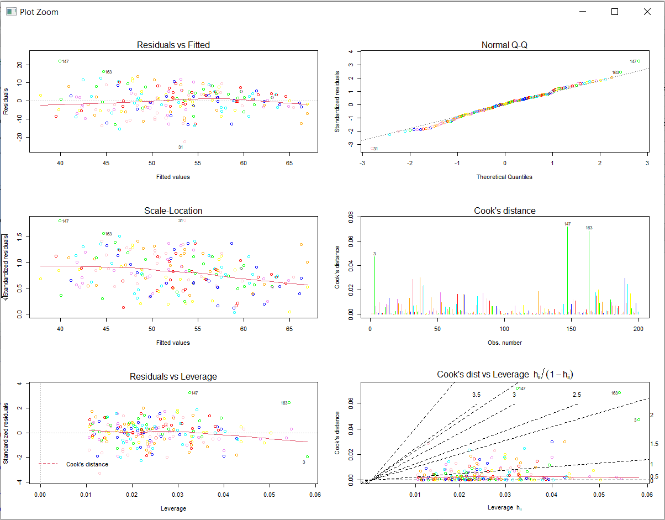

detach(hsb2)

CONCLUSION:ALL COMMAND HAVE BEEN UCCESFULLY EXECUTED AND PLOTTED IN RSTUDIOS.